
GENERAL SUPPLIES FOR ALL GRADES SPANISH LANGUAGE

- One pack of “3-holes” clear, sheet protectors (Please place in holes of plastic folder)
- One plastic folder (solid color) with prongs
- Two composition books (Label: with child’s name and “Lengua”) First grade parents, please do not purchase with the three handwriting guide lines.)
- Zippered pencil pouch (All materials #5-#13 should be kept here at all times).
- Pencils (Minimum of three sharpened pencils in the pouch at all times)
- Two red ink pens (Please replace as you see the need.)
- A ruler
- Scissors
- Glue Stick
- Two big erasers
- A box of twelve color pencils
- One box of 16 Crayola crayons
- Pencil sharpener with tank (Please replace when lost or broken)
1ST GRADE

- Cotton or nylon drawstring bag
- Spanish-English Pocket Dictionary : Please keep at home to use as resource
- Spanish (only) Dictionary: Please keep at home to use as resource
2ND GRADE

- Spanish-English Pocket Dictionary : Please keep at home to use as resource
- Spanish (only) Dictionary: Please keep at home to use as resource
3RD 4TH 5TH GRADE

- Graph Filler paper

Please label able supplies with child’s name. GRACIAS ☺

SPANISH MANDATORY BOOKS
1st grade | 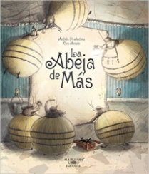  “La abeja de mas”, Pi Andreu | 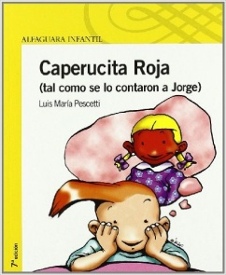  Caperucita Roja, Luis Maria Pescetti
2nd grade | 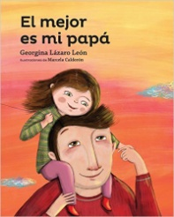  “El mejor es mi papa”, Georgina Lázaro León | 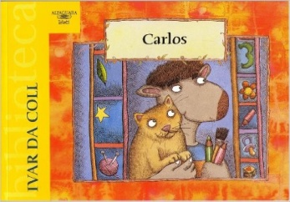  Carlos, Ivar Da Coll
3rd grade | 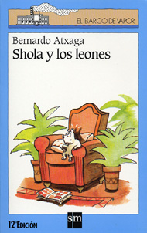  “Shola y los leones”, Bernardo Atxaga | 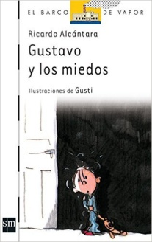  Gustavo y los miedos, Ricardo Alcántara
4th grade | 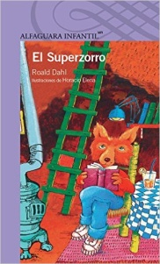  “Superzorro”, Roald Dahl | 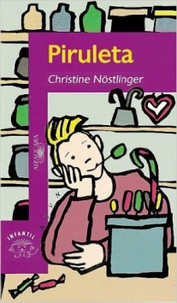  “Piruleta” Christine Nostlinger
5th grade | 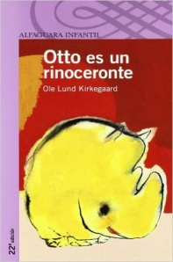  “Otto es un rinoceronte” Ole Lund Kirkegaard | 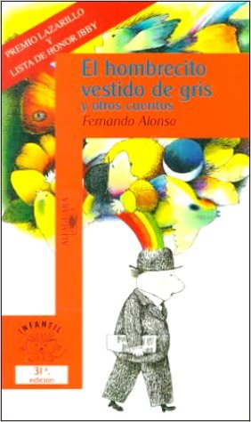  “El hombrecito vestido de gris”, Fernando Alonso

