

**SPANISH SUMMER READING**

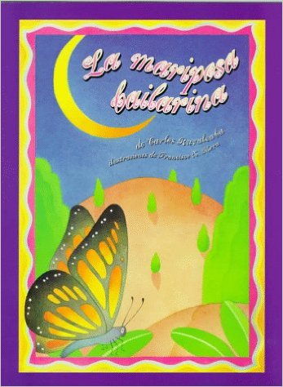**WELCOME TO SECOND GRADE!**

**Dear Future 2nd Grade Students & Parents,**

**This summer you will be required to read the book:**

**“La mariposa bailarina” by Ricardo Ruvalcaba**

**You will need to complete a short book report including:**

* **Book title**
* **Author**
* **A drawing of your favorite part**
* **Five sentences about the story**
* **Due date: Friday, August 26th 2016**

**Read, read, read, and enjoy your summer! We are very excited to meet you!**

**Thank you,**

***Spanish Department***



**SPANISH SUMMER READING**

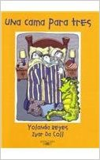**WELCOME TO THIRD GRADE!**

**Dear Future 3rd Grade Students & Parents,**

**This summer you will be required to read the book:**

**“Una cama para tres” by Yolanda Reyes.**

**You will need to complete a short book report including:**

* **Book title**
* **Author**
* **A drawing of your favorite part**
* **Main and secondary characters**
* **One paragraph summary(who, when, where and how)**
* **Due date: Friday, August 26th 2016**

**Read, read, read, and enjoy your summer! We are very excited to meet you!**

**Thank you,**

***Spanish Department***



**SPANISH SUMMER READING**

**WELCOME TO FOURTH GRADE!**

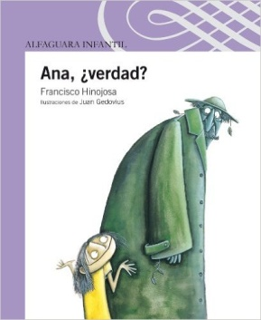**Dear Future 4th Grade Students & Parents,**

**This summer you will be required to read the book**

**“Ana, ¿Verdad?” by Francisco Hinojosa.**

**You will need to complete a short book report including:**

* **Book title**
* **Author**
* **A drawing of your favorite part**
* **Main and secondary characters**
* **Two paragraph summary (who, when, where and how)**
* **Due date: Friday, August 26th 2016**

**Read, read, read, and enjoy your summer! We are very excited to meet you!**

**Thank you,**

***Spanish Department***



**SPANISH SUMMER READING**

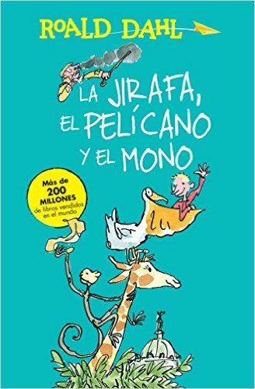**WELCOME TO FIFTH GRADE!**

**Dear Future 5th Grade Students & Parents,**

**This summer you will be required to read the book**

**“La jirafa, el pelícano y el mono” by Roald Dahl.**

**You will need to complete a short book report including:**

* **Book title**
* **Author**
* **A drawing of your favorite part**
* **Main and secondary characters**
* **Three paragraph summary (who, when, where and how)**
* **Due date: Friday, August 26th 2016**

**Read, read, read, and enjoy your summer! We are very excited to meet you!**

**Thank you,**

***Spanish Department***