Fourth Grade Required Book List
2016-2017
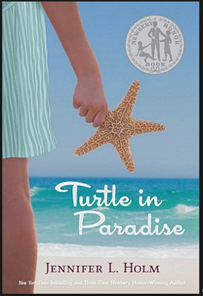

Turtle in Paradise, by Jennifer L. Holm; ISBN 978-0-375-83690-9

In the Year of the Boar and Jackie Robinson; ISBN-10: 0-06-440175-8

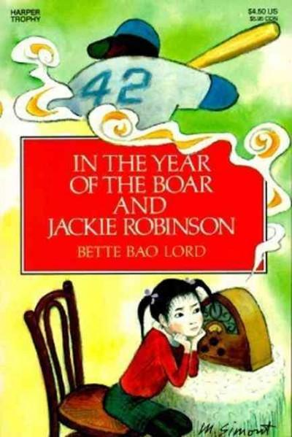

Clara Barton, by Janet & Geoff Benge; ISBN 1-883002-50-8

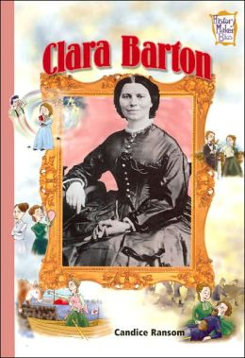
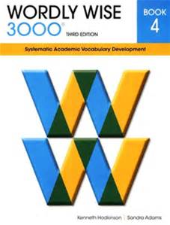

Wordly Wise 3000, Book 4; ISBN 978-0-8388-7604-6

