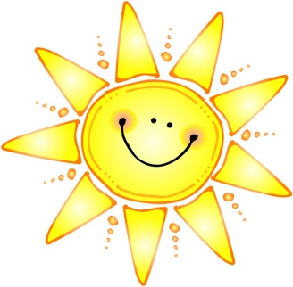

**Summer Reading 2016  
Welcome to 3rdGrade!**

Dear Future 3rd grade Students & Parents,

This summer you will be required to read two books. You may choose 2 books from the 3 that are listed below.   
  
Complete a book report for each of the 2 books you choose to read.

1. Third Grade Angels by Jerry Spinelli
2. Cendrillon by Robert D. San Souci
3. The Class Election from the Black Lagoon by Mike Thaler

**Your child will be required to take the AR test on the 2 books they chose to read.**

Enjoy your summer and we are very excited to meet you!  
  
  
-The Third Grade Teachers

