Third Grade Book List
2016-2017
Books & Novels
The Intuits  By: Kevin Cunningham | The Kid Who Ran For President  By: Dan Gutman | Serafina’s Promise  By: Ann Burg
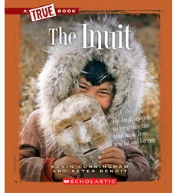 | 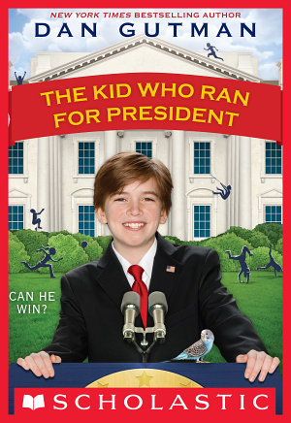 | 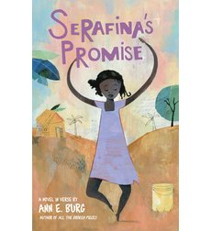

Additional Support Materials
Wordly Wise 3000  Book 3:  Third Edition  ISBN # 978-0-8388-7603-9  Or  ISBN # 083887603X | Ready Florida ELA (LAFS) Instruction  + FL Assessments  ISBN#978-1-4957-0678-3  http://www.curriculumassociates.com/products/ready-florida-overview.aspx#ordernow
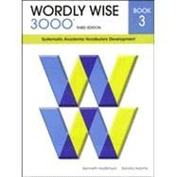 | 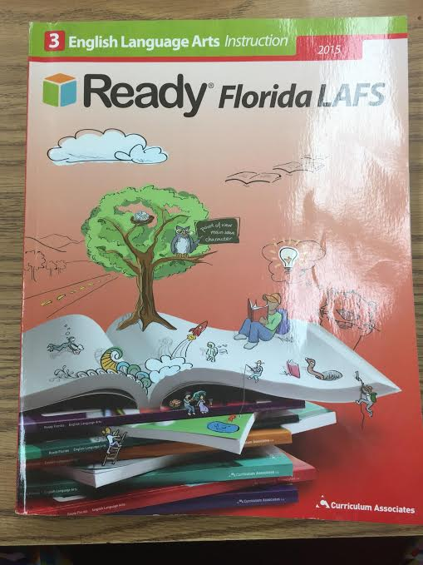
*Books are available at Get Smart and through the Sunset PTA

