Title of the book | Author
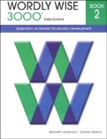  Wordly Wise 3000-Book 2 | School Specialty, Inc.  (3rd Edition)
Molly’s Pilgrim  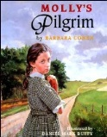 | Barbara Cohen
Keena Ford And The Field Trip Mix Up  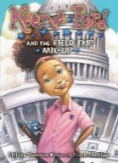 | Melissa Thomson
Magic Tree House Fact Tracker: Heroes for All Times  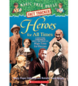 | Mary Pope Osborne and  Natalie Pope Boyce
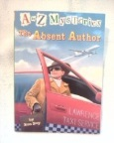  A to Z Mysteries:  The Absent Author | Ron Roy
Ready Florida ELA (LAFS) Instruction- 2nd grade  ISBN: 978-1-4957-0557-1 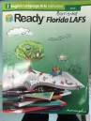 | Curriculum Associates
2nd Grade Classroom Book List 2016-2017
Wordly Wise 3000-Book 2 | School Specialty, Inc.  (3rd Edition)

