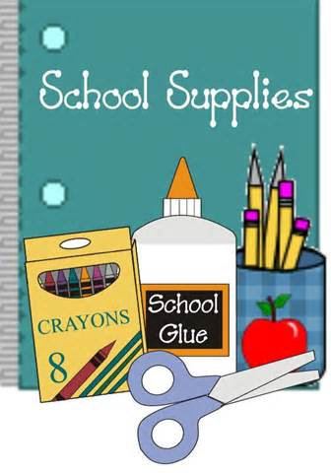[](http://www.google.com/imgres?imgurl=http://sunset.dadeschools.net/Site/images/banner3.jpg&imgrefurl=http://sunset.dadeschools.net/about.htm&usg=__e8qwJLQTHP2uDtAcMsAx6XuJC70=&h=822&w=812&sz=81&hl=en&start=3&zoom=1&tbnid=xZnd_F6gu978GM:&tbnh=144&tbnw=142&ei=wyCQT5GhMoy08ATPnIn0Aw&prev=/search?q=sunset+elementary&um=1&hl=en&safe=active&sa=N&rlz=1T4RNQN_enUS479US480&tbm=isch&um=1&itbs=1)

**First Grade**

**Supply List 2016-2017**

**Please LABEL EACH ITEM with your child’s name:**

* 1 book bag (No rolling bags/Zuca bags)
* 4 Mead composition notebook ( one of each: blue, red, black, and green covers labeled with your child’s name)
* 3 plastic duo-tang (2 pocket folder) with prongs (one of each: red. green and blue labeled with your child’s name)
* 2 reams of white copy paper
* 1 pair of headphones with child’s name

**Class Resource Books:**

* 1 copy of the Wordly Wise Vocabulary Book (Available for purchase at Sunset’s PTA Room)

**Please LABEL EACH ITEM and place in child’s pencil case:**

* 1 pencil case
* 2 glue sticks (Suggestion: Purchase extras to replace as needed.)
* 1 glue bottle
* 2 packs of #2 pencils
* 1 box of Crayola crayons -24 colors (Suggestion: Purchase extras to replace as needed.)
* 1 pair of Blunt-Tip Scissors
* 1 sharpener with lid

**WISH LIST**:

* 1 box of baby wipes or refill pack
* 1 square box of Kleenex tissue
* 1 pack of sheet protectors
* 1 pack of gallon size Ziploc bags and/or quart size Ziploc bags
* I box of NONERASABLE blue or red pen