**Sunset Elementary**

**First Grade Reading Resources**

**2016-2017**

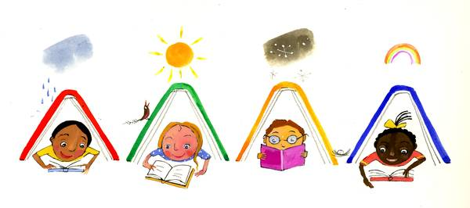

|  |  |  |  |  |  |  |
| --- | --- | --- | --- | --- | --- | --- |
| |  |  |  |  |  |  | | --- | --- | --- | --- | --- | --- | | |  |  | | --- | --- | | [Johnny Appleseed: My Story](http://www.arbookfind.com/bookdetail.aspx?q=57572&l=EN&slid=11499667)http://www.arbookfind.com/images/book_tn_left.jpg |  | |  | | | [**Johnny Appleseed: My Story**](http://www.arbookfind.com/bookdetail.aspx?q=57572&l=EN&slid=11499667) by David L. Harrison  This story is an introduction to the man who became known as Johnny Appleseed. | |
| |  |  |  |  | | --- | --- | --- | --- | | |  | | --- | | [Last Stop on Market Street](http://www.arbookfind.com/bookdetail.aspx?q=171387&l=EN&slid=11499936) | |  | | [**Last Stop on Market Street**](http://www.arbookfind.com/bookdetail.aspx?q=171387&l=EN&slid=11499936)  by Matt de la Peña A young boy rides the bus across town with his grandmother and learns to appreciate the beauty in everyday things.  ****Newberry Winner 2016**** | |
| |  |  |  |  | | --- | --- | --- | --- | | |  | | --- | | [The Legend of Old Befana](http://www.arbookfind.com/bookdetail.aspx?q=52166&l=EN&slid=11681805) | |  | | [**The Legend of Old Befana**](http://www.arbookfind.com/bookdetail.aspx?q=52166&l=EN&slid=11681805) by Tomie De Paola  Because Befana's household chores kept her busy, she searches to this day, leaving gifts for children on the Feast of the Three Kings. | |
| |  |  |  |  | | --- | --- | --- | --- | | |  | | --- | | [George Washington and the General's Dog](http://www.arbookfind.com/bookdetail.aspx?q=83262&l=EN&slid=11500242) | |  | | [**George Washington and the General's Dog**](http://www.arbookfind.com/bookdetail.aspx?q=83262&l=EN&slid=11500242) by Frank Murphy This book recounts events in the life of George Washington that focus on his fondness for animals. | |
| |  |  |  |  | | --- | --- | --- | --- | | |  | | --- | | [http://tse1.mm.bing.net/th?&id=OIP.M215a59c4393c8e303d53fa43dd6cae34o0&w=237&h=237&c=0&pid=1.9&rs=0&p=0&r=0](http://www.bing.com/images/search?q=quickest+kids+in+clarksville+image&view=detailv2&&id=8D157F6509A748084E5446FEE2B20EF07CDC70D0&selectedIndex=2&ccid=IVpZxDk8&simid=608011497178858857&thid=OIP.M215a59c4393c8e303d53fa43dd6cae34o0) | |  | | **The Quickest Kid in Clarksville** by Pat Zietlow Miller  Growing up in the segregated town of Clarksville, Tennessee, in the 1960s, Alta's family cannot afford to buy her new sneakers, but she still plans to attend the parade celebrating her hero Wilma Rudolph's three Olympic gold medals. ridges | |
| [Dolphins at Daybreak](http://www.arbookfind.com/bookdetail.aspx?q=17563&l=EN&slid=11500711)   |  |  |  |  | | --- | --- | --- | --- | | |  | | --- | |  | |  | | [**Dolphins at Daybreak**](http://www.arbookfind.com/bookdetail.aspx?q=17563&l=EN&slid=11500711) by Mary Pope Osborne The magic tree house takes Jack and Annie deep into the sea where they meet up with dolphins, sharks, and octopi as they search for the answer to an ancient riddle. | |
| |  |  |  |  | | --- | --- | --- | --- | | |  | | --- | | [High Tide in Hawaii](http://www.arbookfind.com/bookdetail.aspx?q=68287&l=EN&slid=11500549) | |  | | [**High Tide in Hawaii**](http://www.arbookfind.com/bookdetail.aspx?q=68287&l=EN&slid=11500549) by Mary Pope Osborne Jack and Annie travel in their magic tree house back to a Hawaiian island of long ago where they make friends, learn how to surf, and encounter a tsunami. | |